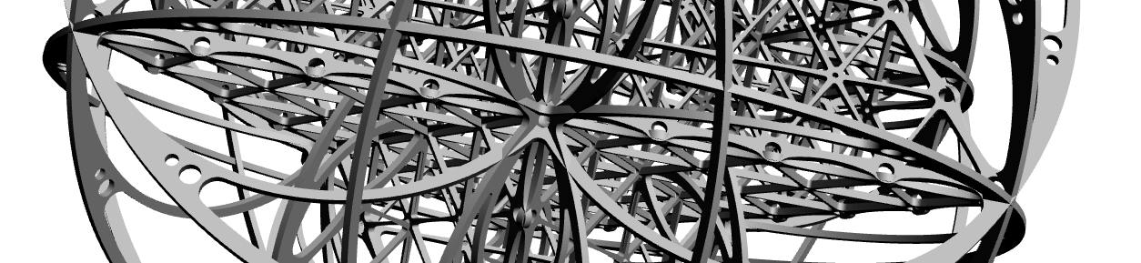

Cosmoscope Interdisciplinary Research Colloquium
Friday 23rd of June, Room BO1, FMM Building, College Lane Campus
University of Hertfordshire

“The universe is not only stranger than we imagine, it is stranger than we can imagine”
J. B. S. Haldane
As above, so below. Hermes Trismegistus
"A universe simple enough to be understood is too simple to produce a mind capable of understanding it." John Barrow
Cosmoscope is an interdisciplinary art and science project led by Simeon Nelson, professor of sculpture at the University of Hertfordshire that will culminate in a monumental sound and light sculpture to be premiered at the Durham Lumiere festival in November this year.

This colloquium will focus on the different areas of science, art and psychology that are coming together to create Cosmoscope. It will be a participatory working session and aims to provide a window into the mechanics of interdisciplinary collaboration.
The multiple aspects of this project are linked by questions about the human perspective and situation in the cosmos. Using the languages of mathematics and physics it embeds the human body and psyche in the wider perspectives of the very small and the very large. It is an exploration of order and disorder as complementary aspects of nature.
It will be of interest to mathematicians, physicists, biologists, creative artists and others.
It is funded by the Wellcome Trust and curated by Artichoke

More info:
http://simeon-nelson.com/index.php/cosmoscope-development/
http://www.herts.ac.uk/cap/projects/present/cosmoscope-sculptural-pavilion

PROGRAMME

Location: Room BO1, FMM Building, College Lane Campus
9.30
Coffee and refreshments

10.00
Welcome and Opening remarks, John Senior, pro vice-chancellor research

10.10
Time, Space and Becoming
Introduction to the themes and development process by prof Simeon Nelson

10.40 - 12.40
Brief presentations from each collaborator on their Cosmoscope research followed by questions

Dr Simon Walker-Samuel Wellcome Trust Senior Research Fellow, UCL Centre for Advanced Biomedical Imaging – Lead Scientific collaborator,
The structure of blood vessel networks and blood flow in the human heart

Dr Richard Bower Professor of Cosmology, Institute for Computational Cosmology, Ogden Centre for Fundamental Physics, Durham University –
The large scale structure of the cosmos

Dr Andrew Goodwin Professor of Materials Chemistry at the University of Oxford
Order and disorder at the atomic and molecular scales

Monia Brizzi London based Chartered Psychologist –
the phenomenological aspects and existential implications of

Rob Godman Reader in Music at the University of Hertfordshire – creating music based on the scientific research and the geometry of the sculpture

Dr Nick Rothwell London based composer, programmer and sound artist – coding programmable lighting based on the physics of the very small, the human scale and the large scale structure of the cosmos

12.40 - 13.20
lunch and general discussion

13.20 - 14.20
panel discussion by participants chaired by Simeon Nelson

14.20
afternoon tea

14.40
The Psychological Implications of Locating Ourselves in the Cosmos
- presentation by Monia Brizzi and Simeon Nelson followed by panel discussion

16.00
Close

For booking enquiries please contact Antoine Proust - a.proust@herts.ac.uk

For any further information please contact Simeon Nelson - S.D.Lockhart-Nelson@herts.ac.uk

