JOB INFORMATION | Freelance Trainee Producer
Contract Type: Fixed term, freelance

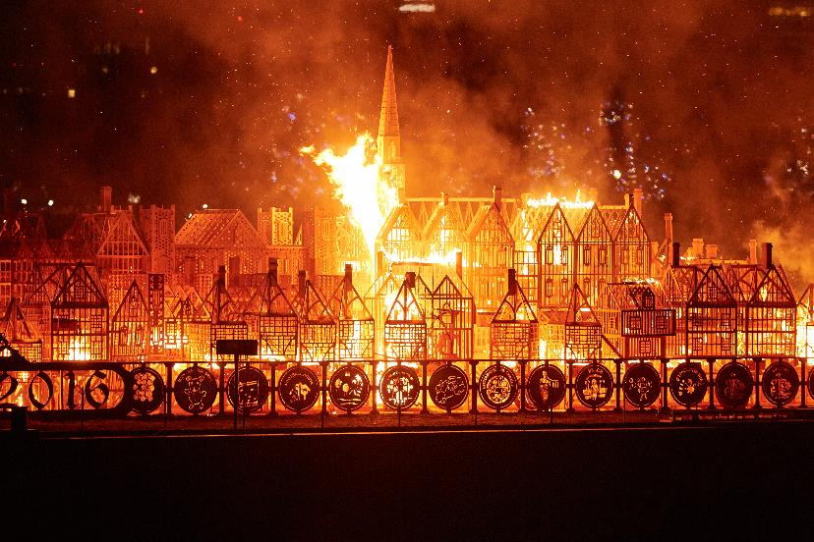

London 1666 David Best in collaboration with Artichoke 4 September 2016

1. Artichoke’s Background

Artichoke was founded ten years ago with its now legendary presentation of Royal de Luxe's The Sultan's Elephant, which brought London to a standstill as audiences were transfixed by the surprise arrival of a giant puppet and a time-travelling elephant. The production brought joy to hundreds of thousands of people as they explored the capital, turned into a playground, magically liberated from its day-to-day traffic clogged restrictions. The production challenged the political arts establishment to rethink its largely venue-based approach to large cultural events and demonstrated the potential for the temporary transformation of the public realm through the creation of a moment of extraordinary art.

Over the last 10 years Artichoke has produced a total of 14 ground-breaking productions ranging from One & Other, Antony Gormley's 2400-hour living portrait on the Fourth Plinth in Trafalgar Square; Peace Camp, a lyrical set of installations created by Deborah Warner and Fiona Shaw for the London 2012 Festival, to the Lumiere Festivals produced in Durham, Derry-Londonderry and London. Lumiere has become a core feature of the cultural landscape and has sent the benchmark for outdoor city-wide winter arts events.

“What was it that made Londoners leave their homes and tourists their hotels during the city’s coldest four nights in years and, as many spontaneously did, lie face up on the freezing tarmac of Oxford Circus? Light is one answer. Art, another. For those four days the art scene in London was transformed.”
John Nathan, The Times on London Lumiere 2016

In September 2016 Artichoke produced London’s Burning, a four-day festival of arts and ideas, to commemorate the 350th anniversary of the Great Fire of London. Across the City of London six international works invited audiences to reflect on the scale and impact of the historical fire, whilst also considering contemporary threats to London’s survival. At the centre of the festival was London 1666, an extraordinary sculptural representation of the sixteenth century skyline of London. Conceived by American artist David Best, the sculpture was built by a team of young Londoners who worked with professional carpenters to realize the artist’s vision. Floated down the Thames on barges, the 120m sculpture was burnt on the river in central London in a spectacular reminder of the events of 4th September 1666.

2. The Role

After the success of Artichoke’s previous project trainee schemes, we are delighted to be able to offer a number of project traineeships on Lumiere, Durham. The scheme offers the opportunity for those who are interested in developing a career in artistic event management to gain experience of working on a large-scale outdoor arts event as well as access to expert knowledge and training seminars with the Lumiere team. The scheme is specifically targeted at those from or based in the ACE North East region.

Three successful candidates will gain experience across a number of roles:

- Production Assistant, supporting the Producer on a variety of practical and administrative aspects of the festival.
- VIP and Artist Liaison – welcoming national and international artists and guests to the city and supporting them during their stay.
- Volunteer Assistant – supporting the recruitment, training and management of festival volunteers.
- Communications Assistant - supporting the communications team to help them deliver their marketing and press strategy, enhancing the live audience experience and the wider reach and impact of the festival.

The provisional programme for Project Trainees includes:
- An introduction to Artichoke (company, projects, staff, policies etc).
- An introduction to Lumiere, the site infrastructure and roles to be undertaken within the placement.
- Training workshops with the Artichoke team and Lumiere production team on a variety of topics. The workshops will aim to give a deeper insight into specific aspects and roles and may include production, general management, communications, volunteer management and learning and participation.
- Where possible, we will support Project Trainee’s interests in other areas of festival production.

PROJECT TRAINEES IN DURHAM

Key Dates

Candidates will be required to be available from Monday 6th November – Monday 20th November. Within that time you will work 12 full days/evenings.
Times will vary depending on the allocated roles each day.

Training workshops and discussions for Project Trainees will be scheduled during the above period.

Fee

The fee for 12 days within the period Monday 6th – Monday 20th November is £70 per day/£840 in total.
In addition, lunchtime and evening meals will be provided when on-site.

Project Trainees will need to be from Durham area or with access to transport to the city centre. No accommodation or travel expenses are provided.

PERSON SPECIFICATION

We are looking for people who:
- Have begun to establish a career in the arts and are able to demonstrate a commitment to developing this career path.
- From or currently based in the ACE North East region.
- Have excellent problem-solving skills and are able to resolve issues that arise in a creative, practical and sensible manner.
- Understand when it’s appropriate to work under their own initiative and when they need further direction or information.
- Have a mature attitude and excellent communications skills.
- Are hardworking, personable and can maintain a positive and realistic outlook under pressure.
- Are able to handle multiple tasks and requests.

Project Trainees will be required to:
- Commit to key dates required of all Project Trainees (the Saturday briefing session and full time hours from Sunday – Monday) plus additional dates if applying for one of the opportunities with an earlier start date.
- Get themselves to and from the centre of Durham.
- Be ready to take on tasks on an hour-by-hour basis and be ready for unexpected requests and eventualities.
- Interact with the public, artists and crew and to provide excellent customer care at all times.
- Adhere to the organisation’s policies and procedures with particular reference to Equal Opportunities, Health and Safety and the Protection of Children and Vulnerable Adults
- Participate in a flexible manner in line with the organisation’s objectives and role and to be willing to undertake duties as reasonably requested within the scope of the Traineeship.

3. Company structure

Artichoke is a charity, funded as a National Portfolio Organisation by Arts Council England. Under the guidance of the Board chaired by Peter Freeman, Helen Marriage, Artichoke’s founding artistic director, leads the organisation. The permanent staff team of 16 is divided across the core departments of Production; Development; Communications and Administration. The core staff devote their time to delivering the programme of large-scale projects initiated by the Artistic Director.

The capacity of the organisation, and the production team in particular, is greatly increased in the period leading up to productions with specialist contractors and freelance staff employed to manage the detailed event planning and technical logistics required by Artichoke’s events.
HOW TO APPLY

Please complete an Application Form an Equal Opportunities form and send them by email to: recruitment@artichoke.uk.com addressed to Louise Dennison with ‘Freelance Trainee Producer’ in the subject heading. You will find a full job description on our website.

Closing date for applications: Monday 11th October 9am.

INTERVIEWS

Interviews will be held on Monday 16th October, details to be confirmed nearer the time. Shortlisted candidates will be contacted by phone or e-mail.

Artichoke is an equal opportunities employer.

