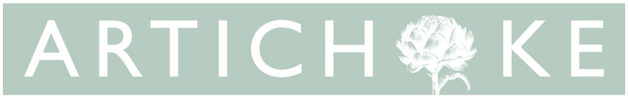
ARTICHOKE TRUST - EQUAL OPPORTUNITIES FORM
Artichoke is an Equal Opportunities employer, and is committed to equality and diversity within our workforce and all opportunities provided by Artichoke. We particularly encourage BAME, disabled people and those from under-represented backgrounds, and people from all communities and industries. We are committed to having a team that is made up of diverse skills, experiences and abilities. Completing this form is not compulsory, but it helps us to monitor how well we are creating equal opportunities for a diverse range of people in our recruitment process.
All information from this form is confidential. It will be kept securely and will not be made available to the recruiting panel or used in the shortlisting process.
Post Applied For
Age | 0-19 | 20-34 |  |  | 35-49 |  |  |  | 50-64 |  | 65+ |  |  |  |  | Prefer not to say
Advertising | Where did you hear about this job? Please state the name of any website, social media, or publication specifically.
Gender | Male |  |  | Female |  |  |  | Intersex |  |  |  | Non Binary |  |  |  |  | Prefer not to say
Ethnicity | Please describe your ethnic background. These categories are based on the 2011 Census ethnic groups. This section of the form is not about your nationality, citizenship or place of birth, but the group you feel you belong to.
 | White
 | British |  |  | Irish |  |  |  | Gypsy or Irish Traveller |  |  |  | White European |  |  |  |  | Any other white background, please state:
 | Mixed/Multiple Ethnic Groups
 | White & Black Caribbean |  |  | White & Black African |  |  |  | White & Asian |  |  |  | Any other mixed / multiple ethnic background, please state:
 | Asian/Asian British
 | Indian |  |  | Pakistani |  |  |  | Bangladeshi |  |  |  | Chinese |  |  |  |  | Any other Asian background, please state:
 | Black/African/Caribbean/Black British
 | African |  |  |  |  |  | Caribbean |  |  |  |  |  |  |  | Any other Black / African / Caribbean Background, please state:
 | Other Ethnic Groups
 | Arab |  |  |  |  |  |  |  |  | Any other ethnic group, please state:
Disability | The Equality Act defines disability as a physical or mental impairment that has a substantial and long-term effect on your ability to perform day to day activities.  Do you consider yourself to have a disability?
 | Yes |  |  |  |  | No |  |  |  |  |  |  | Prefer not to say
 | If you require any reasonable adjustments in order to attend an interview, please let us know if and when you are offered an interview.
Sexual Orientation | The terminology below is recommended by Stonewall.
 | Bisexual |  | Gay man |  |  | Gay woman / Lesbian |  |  |  | Heterosexual / Straight |  |  |  | Prefer to self-describe: |  |  |  | Prefer not to say
Dependents | Do you have any dependents? Dependents may include children, elderly people or other people who rely on you for care.
 | Yes |  |  |  |  |  | No |  |  |  |  |  |  |  | Prefer not to say

Thank you for taking the time to complete this form. You have helped us to monitor our commitment to treating everybody equally.

