JOB INFORMATION | LUMIERE DURHAM PRODUCER (FREELANCE)

Fee: Total fee of £16,000

Contract Type: This is a freelance position offered on a fixed term basis. The role will be part time throughout June - September 2021 moving to full time in October & November 2021.

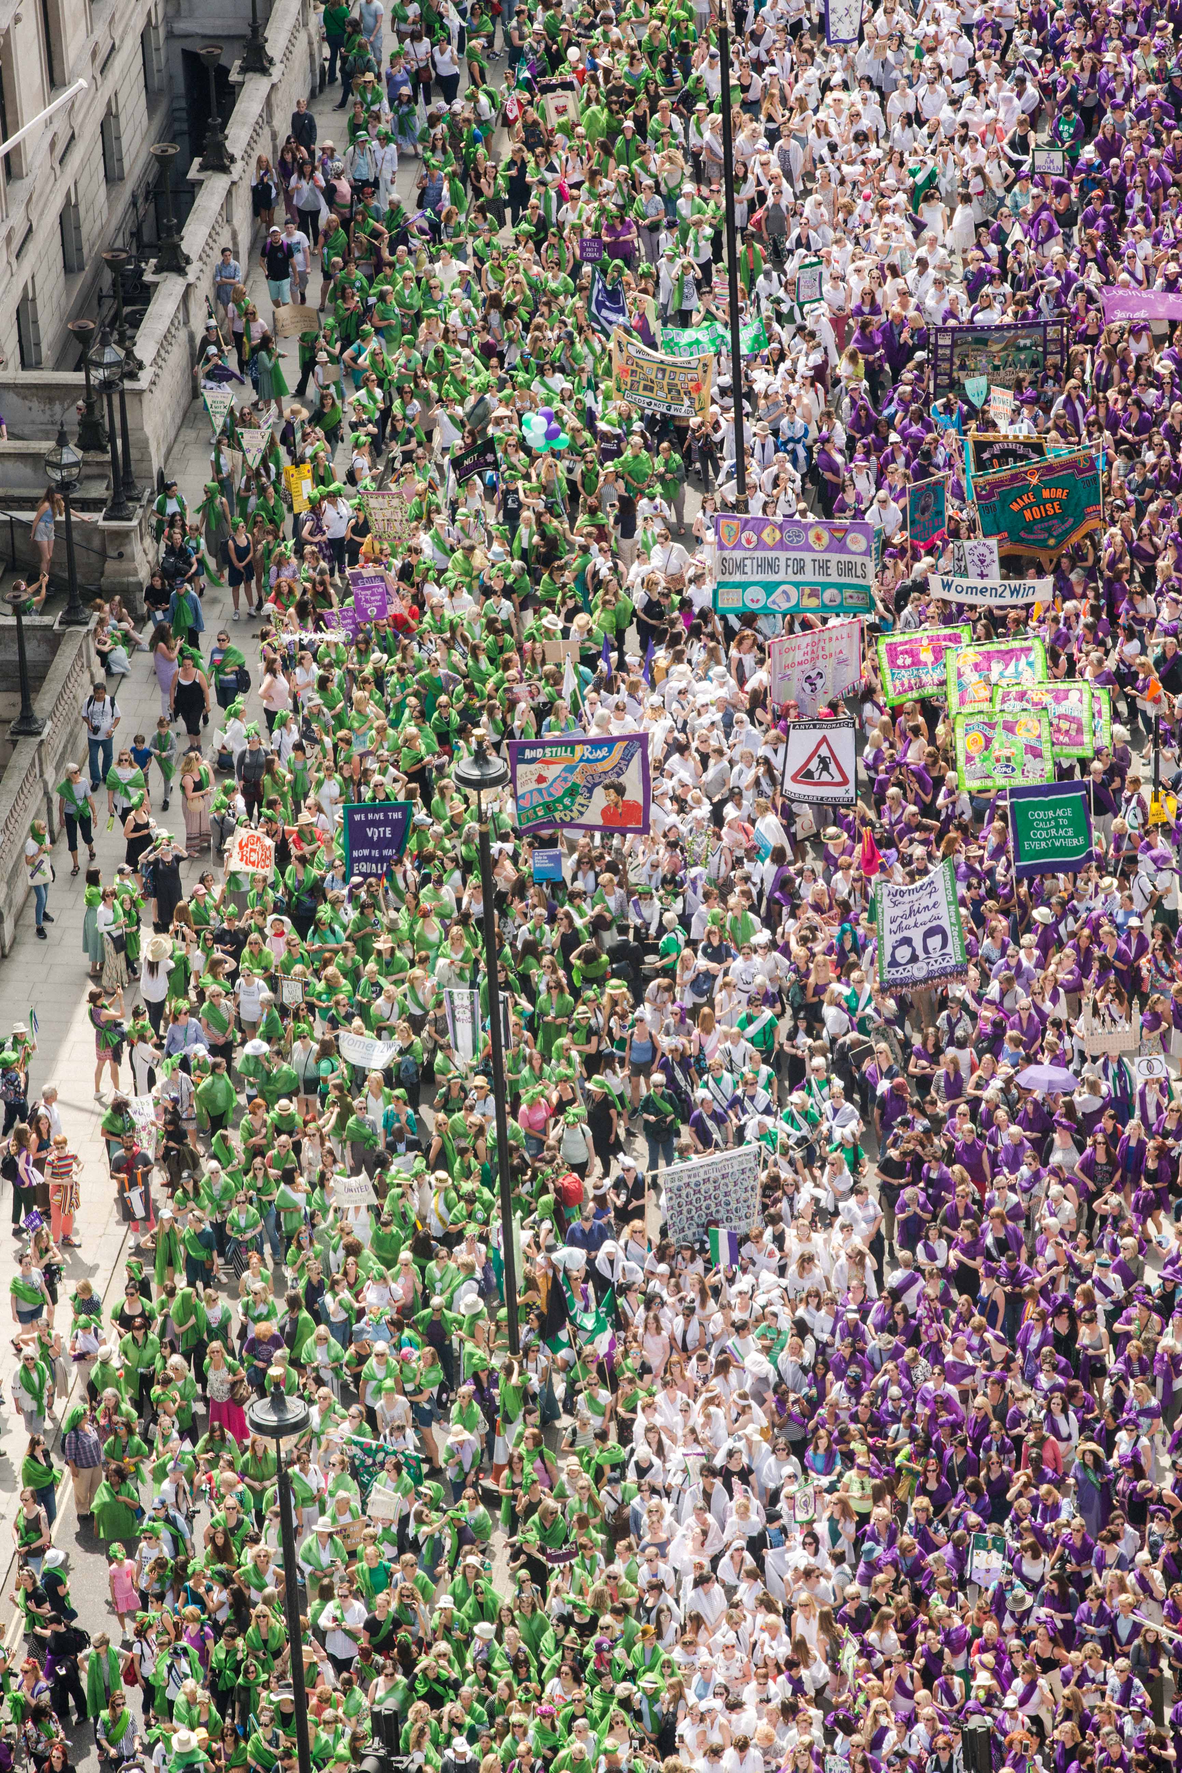
Photo: PROCESSIONS 2018 London, an Artichoke Project Commissioned by 14-18 NOW. Photo by Amelia Allen

1. Artichoke Background

Artichoke was founded in 2005 with its now legendary presentation of Royal de Luxe's The Sultan's Elephant, which brought London to a standstill as audiences were transfixed by the surprise arrival of a giant puppet and a time-travelling elephant. The production brought joy to hundreds of thousands of people as they explored the capital, turned into a playground, magically liberated from its day-to-day traffic clogged restrictions. The production challenged the political arts establishment to rethink its largely venue-based approach to large cultural events and demonstrated the potential for the temporary transformation of the public realm through the creation of a moment of extraordinary art.

Over the last 15 years Artichoke has produced a total of 23 ground-breaking productions ranging from PROCESSIONS, a living portrait of women in the 21st Century celebrated across the UK; One & Other, Antony Gormley's 2400-hour living portrait on the Fourth Plinth in Trafalgar Square; Peace Camp, a lyrical set of installations created by Deborah Warner and Fiona Shaw for the London 2012 Festival, to the Lumiere Festivals produced in Durham, Derry-Londonderry and London. Lumiere has become a core feature of the cultural landscape and has sent the benchmark for outdoor city-wide winter arts events.

“What was it that made Londoners leave their homes and tourists their hotels during the city’s coldest four nights in years and, as many spontaneously did, lie face up on the freezing tarmac of Oxford Circus? Light is one answer. Art, another. For those four days the art scene in London was transformed.” John Nathan, The Times on London Lumiere 2016

In September 2016 Artichoke produced London’s Burning, a four-day festival of arts and ideas, to commemorate the 350th anniversary of the Great Fire of London. Across the City of London six international works invited audiences to reflect on the scale and impact of the historical fire, whilst also considering contemporary threats to London’s survival. At the centre of the festival was London 1666, an extraordinary sculptural representation of the sixteenth century skyline of London. Conceived by American artist David Best, the sculpture was built by a team of young Londoners who worked with professional carpenters to realize the artist’s vision. Floated down the Thames on barges, the 120m sculpture was burnt on the river in central London in a spectacular reminder of the events of 4th September 1666.

Most recently, Artichoke produced Lumiere Durham for its 10th anniversary. The audience braved incessant rain to experience four spectacular evenings showcasing 37 light artworks by international and local artists across Durham City. First estimates put the number of visitors at 165,000, bringing the number of people who have enjoyed the festival since it began in 2009 to just over one million.

2. The Role

Working as a key member of the production team, the Producer will work closely with the Artistic Director and Senior Producer to deliver Lumiere, the UK’s largest light festival, which will take place in Durham between 18th and 21st November 2021.

The role requires an excellent team player with the ability to respond quickly in high pressured environments, a keen eye for detail and excellent communication skills.

HOW TO APPLY

- Please read the information in the job description and person specification on the following pages.

- Complete the application form which can be found here: https://forms.office.com/Pages/ResponsePage.aspx?id=U12ioNFO_0yr1KNqkG0KcjXsaa1QzeJLifnXInUdtftUQU9WT0dUSTA1VlY0QlYwTEpINlpXQzBOTC4u

- Details about applying via alternative methods are available, please contact: recruitment@artichoke.uk.com

Application deadline: Monday 19th April at 9am.

Interview date: W/C 26th April 2021. Details to be confirmed.

Start date: June 2021 / depending on notice period.

Artichoke is committed to equality of opportunity and access for all and welcomes and encourages applications from everyone, irrespective of their age, gender, class, marital status, nationality, ethnic origin, disability, religious belief or sexual orientation.

Please do email recruitment@artichoke.uk.com to arrange a call if you have any questions or queries about the role.

JOB DESCRIPTION – LUMIERE DURHAM 2021 PRODUCER

Job Title:

Lumiere Durham 2021 Producer

Based:

London, or the North East
Once restrictions allow, Artichoke will return to work in Toynbee Studios, London E1.
The Lumiere Office be based in Durham from 1 November until 24 November.

Reports To:

Senior Producer

Key Relationships:

Artistic Director, Head of Learning and Participation, Production Co-ordinator, Assistant Producers, General Manager, Production managers and technical teams, local partners, artists.

KEY RESPONSIBILITIES

Working as a key member of the production team, the Producer will work closely with the Artistic Director and Senior Producer to deliver Lumiere, the UK’s largest light festival, which will take place in Durham between 18th and 21st November 2021.

The role requires an excellent team player with the ability to respond quickly in high pressured environments, a keen eye for detail and excellent communication skills.

Project Management

- Work closely with artists to develop and realise their artistic vision and produce the work of specific Lumiere artists, under the direction of Artichoke’s Senior Producer;
- Obtain up to date technical specifications from artists where required
- Work closely with production managers and technical teams to deliver work safely, on time and within budget;
- Undertake feasibility studies, prepare budgets, manage artist schedules, confirm permissions and access requirements;
- Ensure project permissions and compliance requirements are secured and fulfilled
- Work with the General Manager on ensuring contracts with Artists accurately reflect projects agreed
- Consult with relevant agencies and eengage with and manage relationships with project stakeholders as requested by Artistic Director and Senior Producer
- Work closely with Artichoke Development and Communications team members in the development and delivery of the festival.
- Ensure all compliance and legal requirements are adhered to.
- Work to ensure relevant information is clearly communicated to the project team throughout delivery.

Financial Management

- To manage delegated areas of project budgets working closely with the Senior Producer and General Manager.

Data collection and reporting

- Work with the General Manager on collecting data for ACE reporting and project evaluations.

PERSON SPECIFICATION

Essential Criteria

Personal qualities | - Supportive; energetic; calm and resourceful;  - Able to work across a range of simultaneous projects and prioritise a complex range of tasks.  - Enjoys working as part of a team and collaborates equally well across a wide demographic of people of all ages.  - Disciplined, motivated and able to manage a busy workload to meet deadlines.
Administration | - Proven organisational and project management skills.  - Financial acumen and ability to manage budgets.  - Proficient written skills  - Computer literate
Producing | - Previous experience of working directly with high profile artists to realise their vision  - Experience of building and sustaining collaborative relationships with project partners across a range of sectors  - Experience of working with technical teams to produce the work of artists to the highest possible production values.  - Substantial experience of working with artists and technical teams to produce arts events in public space.  - Experience of producing large-scale work.  - Understanding of the Event Control process and protocols relating to the management of live events  - Knowledge of Health & Safety and Risk Assessments relating to work in the public realm.
Personnel | - Excellent people management skills  - A full understanding of diversity and safeguarding issues.
Communication | - Excellent inter-personal skills: ability to relate to a wide group of people in a professional manner with tact and diplomacy.  - Excellent verbal and written communication skills with the ability to convey information, clearly, effectively and persuasively.  - Practical problem-solving abilities, able to deal with unexpected problems in a calm and efficient manner.

Additional Desirable Criteria | - Proficiency in French  - Experience of working with volunteers

General requirements required of all Artichoke staff

- To contribute to the development of a professional working and learning environment within the organisation.
- To contribute to the organisation’s understanding of diversity and its implications for the arts and to ensure that this understanding informs all the organisation’s activities.
- To ensure adherence to the organisation’s policies and procedures with particular reference to equal opportunities and health and safety.
- To work in a flexible manner in line with the organisation’s corporate objectives and role and to be willing to undertake other duties as reasonably requested.
- To provide excellent customer care in dealings with the public.
- To deputise for senior colleagues as appropriate.
- The ability and willingness to work flexible hours and to travel as required

This job description is not exhaustive and the post holder may be required to undertake other such duties from time to time.

SUMMARY OF TERMS AND CONDITIONS

Fee: Fixed fee of £16,000.

Contract: This is a fixed term freelance contract until November 2021.

Days required: This is a flexible freelance role with an average commitment of 2 days per week from June-August, 3 days per week in September moving to full time working exclusively for Artichoke in October & November 2021.

Location: The Artichoke team are currently working remotely from home due to the changing Covid-19 situation. The ability to work from home is therefore essential. Once Covid regulations change, the post is usually based in Artichoke’s offices, currently in London E1, with regular travel to Durham.

.

