Job information | Development Assistant
Salary: £22,500 gross per year
Contract type: Full time, permanent

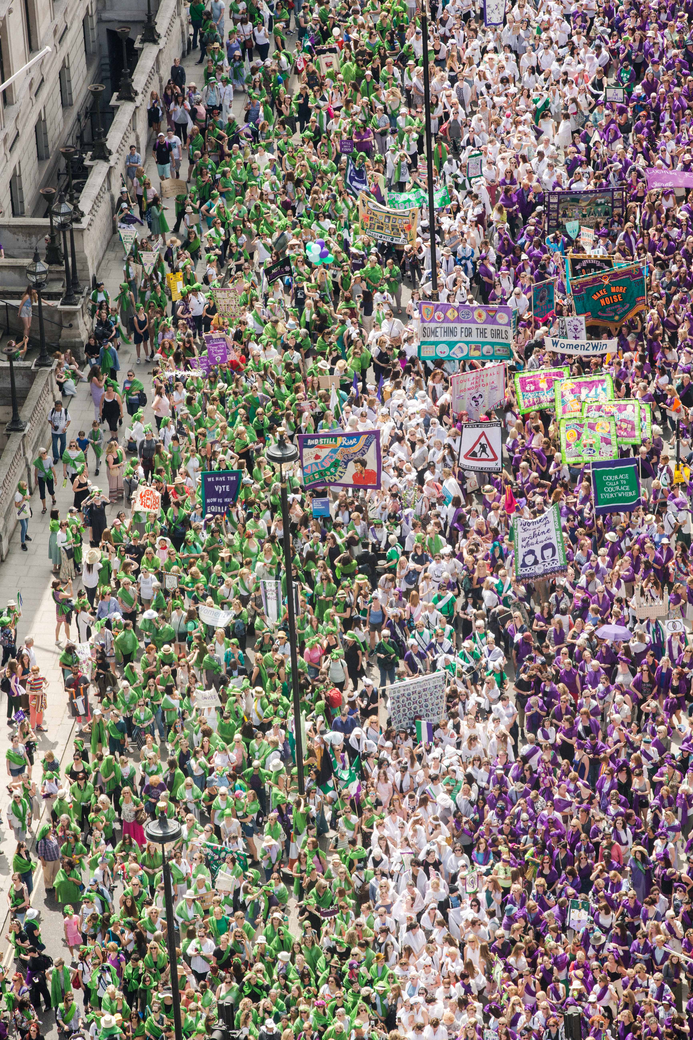
Photo: PROCESSIONS 2018 London, an Artichoke Project Commissioned by
14-18 NOW. Photo by Amelia Allen

1. Artichoke Background

Artichoke was founded in 2005 with its now legendary presentation of Royal de Luxe's The Sultan's Elephant, which brought London to a standstill as audiences were transfixed by the surprise arrival of a giant puppet and a time-travelling elephant. The production brought joy to hundreds of thousands of people as they explored the capital, turned into a playground, magically liberated from its day-to-day traffic clogged restrictions. The production challenged the political arts establishment to rethink its largely venue-based approach to large cultural events and demonstrated the potential for the temporary transformation of the public realm through the creation of a moment of extraordinary art.

Over the last 15 years Artichoke has produced a total of 23 ground-breaking productions ranging from PROCESSIONS, a living portrait of women in the 21st Century celebrated across the UK; One & Other, Antony Gormley's 2400-hour living portrait on the Fourth Plinth in Trafalgar Square; Peace Camp, a lyrical set of installations created by Deborah Warner and Fiona Shaw for the London 2012 Festival, to the Lumiere Festivals produced in Durham, Derry-Londonderry and London. Lumiere has become a core feature of the cultural landscape and has sent the benchmark for outdoor city-wide winter arts events.

“What was it that made Londoners leave their homes and tourists their hotels during the city’s coldest four nights in years and, as many spontaneously did, lie face up on the freezing tarmac of Oxford Circus? Light is one answer. Art, another. For those four days the art scene in London was transformed.” John Nathan, The Times on London Lumiere 2016

In September 2016 Artichoke produced London’s Burning, a four-day festival of arts and ideas, to commemorate the 350th anniversary of the Great Fire of London. Across the City of London six international works invited audiences to reflect on the scale and impact of the historical fire, whilst also considering contemporary threats to London’s survival. At the centre of the festival was London 1666, an extraordinary sculptural representation of the sixteenth century skyline of London. Conceived by American artist David Best, the sculpture was built by a team of young Londoners who worked with professional carpenters to realize the artist’s vision. Floated down the Thames on barges, the 120m sculpture was burnt on the river in central London in a spectacular reminder of the events of 4th September 1666.

Most recently, Artichoke produced Lumiere Durham for its 10th anniversary. The audience braved incessant rain to experience four spectacular evenings showcasing 37 light artworks by international and local artists across Durham City. First estimates put the number of visitors at 165,000, bringing the number of people who have enjoyed the festival since it began in 2009 to just over one million.

2. The Role

We are looking for a new Development Assistant to join our award-winning fundraising team. You will play a key role in helping us raise funds for our ambitious projects and gain experience in all areas of fundraising, from corporate sponsorship, to trusts and foundations and individual giving. We have several new projects in the making, so it is an exciting time to join Artichoke.

3. How to apply

- Please read the information in the job description and person specification on the following pages.
- Complete the application form which can be found here: https://forms.office.com/Pages/ResponsePage.aspx?id=U12ioNFO_0yr1KNqkG0KcjXsaa1QzeJLifnXInUdtftUOVZZRzczTjNFSEU1RUxHMEZNNERFTjFMNS4u
- Details about applying via alternative methods are available, please contact: recruitment@artichoke.uk.com

Application deadline: 9am Tuesday 18th May 2021

Interview date: 20th May or w/c 24th May. Details to be confirmed.

Start date: Immediate.

Artichoke is an Equal Opportunities employer, and is committed to equality and diversity within our workforce and all opportunities provided by Artichoke. We particularly encourage People of Colour, d/Deaf and disabled people and those from under-represented backgrounds to apply. Positive action may be used in the recruitment process to select a candidate from a group that is disadvantaged or under-represented in our workforce, if the candidates in question are of equal merit.

Artichoke is a Disability Confident Committed employer.

Please do email recruitment@artichoke.uk.com to arrange a call if you have any questions or queries about the role.

DEVELOPMENT ASSISTANT | JOB DESCRIPTION AND PERSON SPECIFICATION

Job Title: Development Assistant

Based: London. Currently E1. Some travel around the UK and Ireland will be required.

Reports To: Trusts & Foundations Manager

Key Relationships: Development Director; Deputy Development Director; Development Team; core staff; Artichoke funders and donors; project stakeholders.
_____________________________________________________________

Key Responsibilities

- Diary management for Development Director including arranging meetings, updating the diary, drafting itineraries, gathering and/or printing relevant fundraising materials.

- Supporting the Development team with writing letters of agreement and thank you letters.

- Overseeing the Letters of Agreement and invoicing process – ensuring their prompt processing and administration – working closely with the Finance Director.

- Supporting the Development team with writing well-researched and persuasive sponsorship proposals, grant applications and reports.

- Proactively making initial telephone enquiries to potential funders; following up by telephone and in writing.

- Assisting with the administration of fundraising events, including managing guest lists and attending Development events and Artichoke events as required.

- Supporting the Deputy Development Director with professional committee management, including preparing minutes, and disseminating further information to members to help support fundraising objectives.

- Being pro-active with independent research.

- Providing general administrative assistance to the Development Team.

- Managing databases, filing systems and internal processes within the Development Department, ensuring that contact details, funder requirements and application deadlines are recorded.

PERSON SPECIFICATION

Essential:
- Some experience of working in an administration role
- Knowledge of the arts and charity sector
- Comfortable working within a high-pressured environment and ability to manage own workload
- Excellent presentation and negotiation skills
- Excellent computer and database skills – Word, Excel, PowerPoint

Desirable:

- An understanding and awareness of working on live events in the public realm
- Previous experience or understanding of working with sponsors and donors

General requirements of all Artichoke Employees

- To contribute to the development of a professional working and learning environment within the organisation.

- To contribute to the organisation’s understanding of diversity and its implications for the arts and to ensure that this understanding informs all the organisation’s activities.

- To ensure adherence to the organisation’s policies and procedures with particular reference to Equal Opportunities and Health and Safety.

- To work in a flexible manner in line with the organisation’s corporate objectives and role and to be willing to undertake other duties as reasonably requested.

- To provide excellent customer care in dealings with the public.

- To deputise for senior colleagues as appropriate.

- The ability and willingness to work flexible hours and to travel as required.

This job description is not exhaustive and the post holder may be required to undertake other such duties from time to time.

SUMMARY OF TERMS AND CONDITIONS:

Salary:
£22,500 per annum, paid monthly in arrears.

Contract:
This is a full time, permanent position, subject to successful completion of the three-month probationary period.

Annual leave:
25 days per annum, plus an additional day’s annual leave for each year’s service (capped at 5 days). You will also be entitled to Bank Holidays.

Probationary period:
3 months

Notice period:
8 weeks notice (two weeks during probationary)

Location:
The Artichoke team are currently working remotely from home due to the changing Covid-19 situation. The ability to work from home is therefore essential. Once Covid regulations change, the post is usually based in Artichoke’s offices, currently in London E1,

Hours of work:
Hours of work will inevitably vary according to the nature of the workload, but generally will be a minimum of 35 hours per week, Monday – Friday, 10am – 6pm. Additional hours may very occasionally be required as necessary for the successful performance of the job.

Benefits:

- Pension: Artichoke is enrolled in a pension scheme with Standard Life. Upon 3 months service payments of 5% can be made into your pension if matched by an equal contribution from yourself (although government policy may require you to make a higher contribution).

- Income protection scheme: Artichoke has an Income protection insurance policy to help if you cannot work because you are ill or injured.

- Employee Assistance programme: An Employee Assistance Programme (EAP) is a counselling and information service. It’s specifically designed to give you the practical and emotional support you may need for everyday life.

- Group Life Insurance: All permanent staff are enrolled in a scheme which will pay 4 times a deceased individual’s salary to a named beneficiary.

- Cycle to work scheme: Artichoke purchases the bike on behalf of the employee at a reduced retail price, and saving the employee tax and NI. The cost of the bike is deducted off employee’s gross monthly salary.

- Season ticket Loan: Artichoke offers an interest free loan to staff needing to pay for a season travel ticket.

- Eye tests and Glasses: Artichoke offers to pay for an eye test every year for staff members, up to £30, and for prescription glasses up to the value of £150.

Artichoke is an equal opportunities employer.

