Job information | Curator, The People’s Gallery
Salary: Fixed fee of £20,000 to cover initial two seasons of work
Contract type: Freelance fixed fee
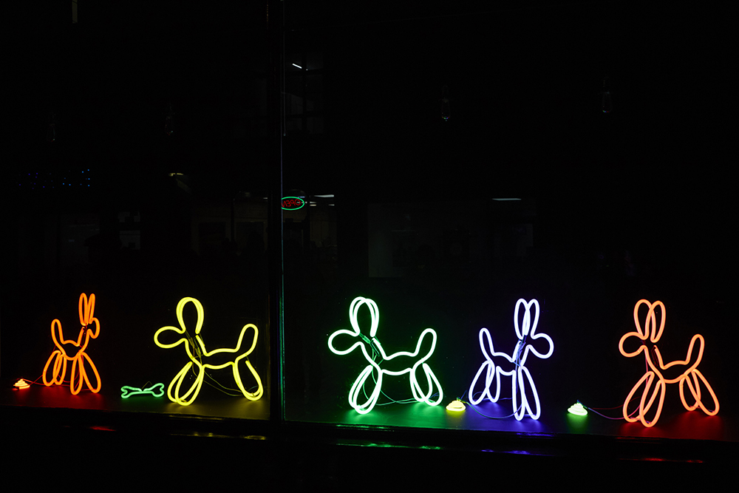

Photo: Neon Dogs, Deepa Mann-Kler. Lumiere Durham 2019. Produced by Artichoke. Photo by Matthew Andrews.

1. Artichoke Background

Artichoke was founded in 2005 with its now legendary presentation of Royal de Luxe's The Sultan's Elephant, which brought London to a standstill as audiences were transfixed by the surprise arrival of a giant puppet and a time-travelling elephant. The production brought joy to hundreds of thousands of people as they explored the capital, turned into a playground, magically liberated from its day-to-day traffic clogged restrictions. The production challenged the political arts establishment to rethink its largely venue-based approach to large cultural events and demonstrated the potential for the temporary transformation of the public realm through the creation of a moment of extraordinary art.

Over the last 15 years Artichoke has produced a total of 23 ground-breaking productions ranging from PROCESSIONS, a living portrait of women in the 21st Century celebrated across the UK; One & Other, Antony Gormley's 2400-hour living portrait on the Fourth Plinth in Trafalgar Square; Peace Camp, a lyrical set of installations created by Deborah Warner and Fiona Shaw for the London 2012 Festival, to the Lumiere Festivals produced in Durham, Derry-Londonderry and London. Lumiere has become a core feature of the cultural landscape and has sent the benchmark for outdoor city-wide winter arts events.

“What was it that made Londoners leave their homes and tourists their hotels during the city’s coldest four nights in years and, as many spontaneously did, lie face up on the freezing tarmac of Oxford Circus? Light is one answer. Art, another. For those four days the art scene in London was transformed.” John Nathan, The Times on London Lumiere 2016

In September 2016 Artichoke produced London’s Burning, a four-day festival of arts and ideas, to commemorate the 350th anniversary of the Great Fire of London. Across the City of London six international works invited audiences to reflect on the scale and impact of the historical fire, whilst also considering contemporary threats to London’s survival. At the centre of the festival was London 1666, an extraordinary sculptural representation of the sixteenth century skyline of London. Conceived by American artist David Best, the sculpture was built by a team of young Londoners who worked with professional carpenters to realize the artist’s vision. Floated down the Thames on barges, the 120m sculpture was burnt on the river in central London in a spectacular reminder of the events of 4th September 1666.

Most recently, Artichoke produced Lumiere Durham for its 10th anniversary. The audience braved incessant rain to experience four spectacular evenings showcasing 37 light artworks by international and local artists across Durham City. First estimates put the number of visitors at 165,000, bringing the number of people who have enjoyed the festival since it began in 2009 to just over one million.

At Artichoke, we are dedicated to doing our bit to redress historic imbalances in the workforce. We want to recognise the positive value of diversity, create a culture of belonging, promote equality and challenge unfair discrimination. As a predominantly white organisation, we are actively working to address under-representation within the company and may use positive action in the recruitment process to select a candidate from a group that is currently under-represented in our team. We aim at all times to recruit the person who best meets our criteria and welcome applications from people of all backgrounds.

2. The People’s Gallery

The People’s Gallery is a new Artichoke project. This ambitious and far-reaching project will create a new contemporary art gallery in the public realm across the four nations of the UK. It will be produced by Artichoke and headed up by the Gallery’s Creative Director. The project will produce two seasons of work a year commissioned from artists for display on paper and digital billboards across the four nations of the UK. The first season is planned for July-August 2022 with the second in January-February 2023.
Each season will be curated around a theme. The themes selected will reflect contemporary concerns and are designed to provoke debate and reflection. A lead artist will be commissioned for each season to interpret the theme, and work with the curator and Creative Director to select and mentor a cohort of up to ten emerging artists to commission as part each exhibition.

3. How to apply

- Please read the information in the job description and person specification on the following pages.
- Complete the application form which can be found here.
- Details about applying via alternative methods are available, please contact: recruitment@artichoke.uk.com

Application deadline: 9am Monday 18th October 2021

Interview date: w/c 25th October or w/c 1st November 2021. Details to be confirmed.

Start date: Immediately.

Artichoke is an Equal Opportunities employer, and is committed to equality and diversity within our workforce and all opportunities provided by Artichoke. We particularly encourage People of Colour, d/Deaf and disabled people and those from under-represented backgrounds to apply. Positive action may be used in the recruitment process to select a candidate from a group that is disadvantaged or under-represented in our workforce, if the candidates in question are of equal merit.

Artichoke is a Disability Confident Committed employer.

Please do email recruitment@artichoke.uk.com to arrange a call if you have any questions or queries about the role.

CURATOR, THE PEOPLE’S GALLERY| JOB DESCRIPTION AND PERSON SPECIFICATION

Job Title: Curator, The People’s Gallery

Based: Flexible. Our offices are in London, E1. Travel around the UK and Ireland will be required.

Reports To: Senior Producer and Artistic Director

Key Relationships: Creative Director People’s Gallery, Communications Director, Head of Learning & Participation, Development Director.
_____________________________________________________________

Key Responsibilities

Project Development and Management
- Work with Artichoke’s Artistic Director and Senior Producer and Creative Director of The People’s Gallery to plan and deliver the first two seasons of The People’s Gallery.
- Develop a robust timetable for the delivery of the project including opportunities to maximise participation.
- Develop and manage relationships with partnership organisations as directed by the Artistic Director and Senior Producer to facilitate the delivery and further development of the project across the four nations of the UK.
- Manage relationships with artists.
- Lead on aspects of production and delivery as directed.
- Collaborate with the Creative Director of the project to develop the role of artist advisory boards to maximise the project potential for the selection of and development of artists.
- Manage contracted project staff and agencies as required.
- Work with the Artistic Director and Senior Producer to ensure project permissions and compliance requirements are fulfilled.
- Identify potential problems before they arise and proactively take measures to resolve them.
- Ensure all compliance and legal requirements are adhered to.

Artistic Curation
- Together with the Artistic Director and Creative Director select and appoint lead artists for each season.
- Work with Artichoke and the Creative Director to determine and select themes for each season.
- Co-ordinate and manage the call-out for emerging artists including criteria for application and assessment.
- Work with Artichoke, the Creative Director and the appointed lead artist to select the longlist and shortlist of artists for live commission and additional artists to feature on the project website.
- Work with Artichoke Communications department to develop appropriate tools and methods of communication to encourage and enable wide reach and diverse response.
- Liaise with Head of Learning & Participation to ensure that the planned participation meets the artistic needs of the project and maximises opportunity for wide involvement.
- Work with the Head of Learning & Participation to ensure the legacy of the project through education links and signposting to future opportunities.
Safeguarding
- Ensure all projects by Artichoke are designed and delivered in line Artichoke’s Safeguarding policy and that all staff are aware of their responsibilities in this respect.
Budget Management
- To prepare and manage project budgets as appropriate, working closely with the Artistic Director, General Manager and Senior Producer.
- To control project expenditure on delegated areas of production budgets within the framework established by the Directors and produce detailed reports as required.
- Research, Consultation and Reporting
- Work with Artichoke’s Development department to create funding applications to support the development of The People’s Gallery.
- Plan and develop a framework to enable evaluation of the project against the key aims and objectives.
- Collect responses and feedback from project participants and partners.
- Prepare full project evaluations.
- Collate and analyse information to produce written scoping reports and recommendations.
General requirements required of all Artichoke staff
- To contribute to the development of a professional working and learning environment within the organisation.
- To contribute to the organisation’s understanding of diversity and its implications for the arts and to ensure that this understanding informs all the organisation’s activities.
- To ensure adherence to the organisation’s policies and procedures with particular reference to equal opportunities and health and safety.
- To work in a flexible manner in line with the organisation’s corporate objectives and role and to be willing to undertake other duties as reasonably requested.
- To provide excellent customer care in dealings with the public.
- To deputise for senior colleagues as appropriate.
- The ability and willingness to work flexible hours and to travel as required.

This job description is not exhaustive and the post holder may be required to undertake other such duties from time to time.

SUMMARY OF TERMS AND CONDITIONS:

Salary:
Fixed fee of £20,000 to cover initial two seasons of work.

Contract:
Freelance fixed fee.

Probationary period:
4 weeks.

Notice period:
4 weeks.

Location:
Our offices are based in London, E1. This post can work from within the UK. There will be expectation to travel to the office at times.

Hours of work:
An estimated average working pattern of 4-7 days per month, with the understanding that during the run up to the delivery period more time will be devoted to the project. Further contract subject to success of fundraising to extend the life of the project.

Artichoke is an equal opportunities employer.

