Job information | Admin Assistant
Salary: £21,500 gross per year
Contract type: One year, fixed-term.

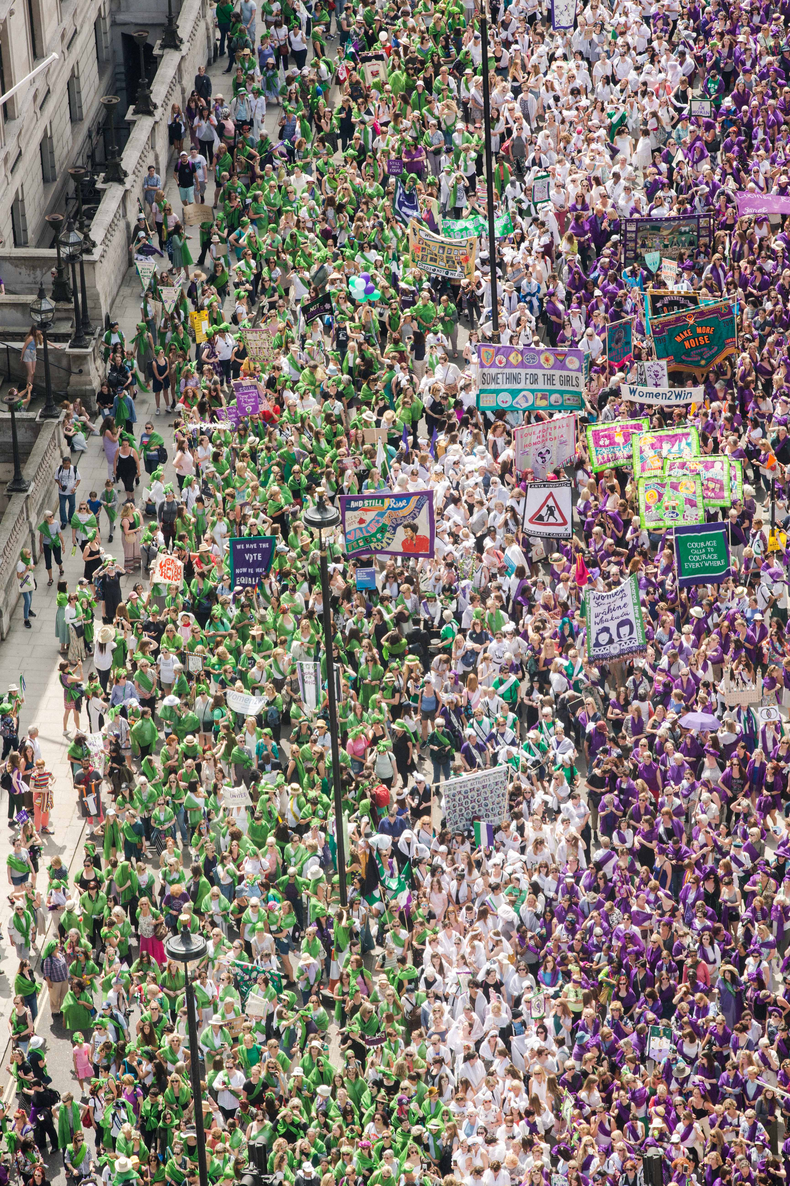
Photo: PROCESSIONS 2018 London, an Artichoke Project Commissioned by
14-18 NOW. Photo by Amelia Allen

1. Artichoke Background

Artichoke was founded in 2005 with its now legendary presentation of Royal de Luxe's The Sultan's Elephant, which brought London to a standstill as audiences were transfixed by the surprise arrival of a giant puppet and a time-travelling elephant. The production brought joy to hundreds of thousands of people as they explored the capital, turned into a playground, magically liberated from its day-to-day traffic clogged restrictions. The production challenged the political arts establishment to rethink its largely venue-based approach to large cultural events and demonstrated the potential for the temporary transformation of the public realm through the creation of a moment of extraordinary art.

Over the last 15 years Artichoke has produced a total of 23 ground-breaking productions ranging from PROCESSIONS, a living portrait of women in the 21st Century celebrated across the UK; One & Other, Antony Gormley's 2400-hour living portrait on the Fourth Plinth in Trafalgar Square; Peace Camp, a lyrical set of installations created by Deborah Warner and Fiona Shaw for the London 2012 Festival, to the Lumiere Festivals produced in Durham, Derry-Londonderry and London. Lumiere has become a core feature of the cultural landscape and has sent the benchmark for outdoor city-wide winter arts events.

“What was it that made Londoners leave their homes and tourists their hotels during the city’s coldest four nights in years and, as many spontaneously did, lie face up on the freezing tarmac of Oxford Circus? Light is one answer. Art, another. For those four days the art scene in London was transformed.” John Nathan, The Times on London Lumiere 2016

In September 2016 Artichoke produced London’s Burning, a four-day festival of arts and ideas, to commemorate the 350th anniversary of the Great Fire of London. Across the City of London six international works invited audiences to reflect on the scale and impact of the historical fire, whilst also considering contemporary threats to London’s survival. At the centre of the festival was London 1666, an extraordinary sculptural representation of the sixteenth century skyline of London. Conceived by American artist David Best, the sculpture was built by a team of young Londoners who worked with professional carpenters to realize the artist’s vision. Floated down the Thames on barges, the 120m sculpture was burnt on the river in central London in a spectacular reminder of the events of 4th September 1666.

Most recently, Artichoke produced Lumiere Durham for its 10th anniversary. The audience braved incessant rain to experience four spectacular evenings showcasing 37 light artworks by international and local artists across Durham City. First estimates put the number of visitors at 165,000, bringing the number of people who have enjoyed the festival since it began in 2009 to just over one million.

2. Diversity and Inclusion

At Artichoke, we are dedicated to doing our bit to redress historic imbalances in the workforce. We want to recognise the positive value of diversity, create a culture of belonging, promote equality and challenge unfair discrimination. As a predominantly white organisation, we are actively working to address under-representation within the company and may use positive action in the recruitment process to select a candidate from a group that is currently under-represented in our team. We aim at all times to recruit the person who best meets our criteria and welcome applications from people of all backgrounds.

Artichoke is a Disability Confident Committed employer.

3. The Role

Artichoke is seeking a skilled, energetic and competent Administration Assistant to join our busy Administration team. The ideal candidate is passionate and driven, and has excellent organisational skills. This role will suit someone who is keen to develop a career within the Arts industry, who can use their initiative and who thrives in a busy environment.

4. How to apply

- Please read the information in the job description and person specification on the following pages.
- Complete the application form which can be found here.
- Details about applying via alternative methods are available, please contact: recruitment@artichoke.uk.com

Application deadline: Wednesday 8th December 9am.

Interview date: w/c Monday 13th December. Details to be confirmed.

Start date: Immediately.

Please do email recruitment@artichoke.uk.com to arrange a call if you have any questions or queries about the role.

ADMINISTRATION ASSISTANT | JOB DESCRIPTION AND PERSON SPECIFICATION

Job Title: Administration Assistant

Based: London. Currently E1. Some travel around the UK may be required on occasion.

Reports To: General Manager

Key Relationships: General Manager and core staff; The Artichoke Administration Assistant will often be the first point of contact for enquiries from members of the public as well as those working with the company on events.

Artichoke is seeking a skilled, energetic and competent Administration Assistant to join our busy Administration team. The ideal candidate is passionate and driven, and has excellent organisational skills. This role will suit someone who is keen to develop a career within the arts and events industry, who can use their initiative and who thrives in a busy environment.

Essential qualities are the ability to manage a varied to-do list and maintain a good level of attention to detail. You will understand the importance of high-quality administrative support in allowing us to achieve our mission, and you’ll be excited to be a part of the team that help makes that mission a reality.

Duties and responsibilities

To provide administrative support to the General Manager and Artichoke Team in the day-to-day running of the organisation.

Administration and communication:

- To act as the primary point of contact for the organisation on a day to day basis through phone, e-mail and letter, including management of the phone system; checking and responding to e-mails and post as directed.
- To keep a log of enquiries about new projects and artists, and report this regularly to Production team.
- To co-ordinate and support internal and external meetings.
- To maintain administrative processes in order to ensure a smooth-running office, including managing post and filing.
- To research and book travel and accommodation arrangements for staff.
- Provide specific additional administrative support to other team members when needed, including diary management and executive support where required.
- To monitor and order office supplies, equipment and stationery, under the direction of the General Manager.
- To assist with basic IT issues that arise, troubleshooting and reporting any problems to our IT provider.
- To maintain the general appearance of the office, making sure it is clean and safe, alerting the General Manager to any issues.
- To oversee the co-ordination of all recycling.
- To maintain Artichoke’s off-site store space and inventory.
- To track and fulfil merchandise orders by post.
- To assist the General Manager with gathering data for Arts Council submissions throughout the year.
- To assist the General Manager in ensuring data is collected, stored and updated in compliance with Artichoke’s Data Protection Policy.

Financial assistance:

- Assist with processing and filing of invoices, credit and debit card paperwork.
- Assist the Finance Manager in uploading invoices and receipts on to Sage Financial database.
- Obtaining necessary budget holder approvals for payments.
- Maintain the office’s petty cash.
- Ensure cheques are processed in a timely manner.

Personnel:

- To assist with inductions for new staff and volunteers.
- To log and respond to incoming volunteer and speculative job enquiries
- Gather and file HR information about employees appropriately using Salesforce database.
- To help with recruitment of new staff, and monitor our equal opportunities practices.

Person Specification

Personal qualities | Essential Desirable  - Energy, drive and a positive approach.  - Ability to work on own initiative and prioritise a range of tasks.  - Have an interest in the work that Artichoke delivers  - A supportive team player who can work efficiently on a wide variety of tasks.
Administration | Essential Desirable  - Proven administrative and organisational skills - Competent computer skills - Previous experience in an administration role - Experience of entry level budget management and managing a database
Office Management | Essential Desirable  - Ability to oversee and manage office and administrative systems with a high degree of reliability and attention to detail. - Ability to plan ahead to support staff and office needs. - Ability to analyse and proactively solve problems - making timely and informed decisions. - Understanding of IT applications. - Previous experience of diary management
Communications | Essential Desirable  - Excellent inter-personal skills: ability to relate to a wide group of people in a professional manner with tact and diplomacy.  - Competent verbal and written communication skills with the ability to convey information effectively and persuasively.

General requirements of all Artichoke Employees

- To contribute to the development of a professional working and learning environment within the organisation.

- To contribute to the organisation’s understanding of diversity and its implications for the arts and to ensure that this understanding informs all the organisation’s activities.

- To ensure adherence to the organisation’s policies and procedures with particular reference to Equal Opportunities and Health and Safety.

- To work in a flexible manner in line with the organisation’s corporate objectives and role and to be willing to undertake other duties as reasonably requested.

- To provide excellent customer care in dealings with the public.

- To deputise for senior colleagues as appropriate.

- The ability and willingness to work flexible hours and to travel as required.

This job description is not exhaustive and the post holder may be required to undertake other such duties from time to time.

SUMMARY OF TERMS AND CONDITIONS:

Salary:
£21,500 per annum, paid monthly in arrears.

Contract:
This is a one year, fixed-term position.

Annual leave:
25 days per annum. You will also be entitled to Bank Holidays.

Probationary period:
3 months

Notice period:
4 weeks’ notice (two weeks during probationary period)

Location:
The post is based in Artichoke’s offices, currently in London E1.

Hours of work:
Hours of work will inevitably vary according to the nature of the workload, but generally will be a minimum of 35 hours per week, Monday – Friday, 10:00am – 6:00pm. Additional hours may occasionally be required as necessary for the successful performance of the job, but overtime or time off in lieu will not be given.

Benefits:

Pension, Income protection scheme, Employee Assistance programme, Group Life Insurance, Cycle to work scheme, Season ticket Loan and Enhanced Parental leave policy.

Artichoke is an equal opportunities employer.

