JOB INFORMATION | COMMUNICATIONS COORDINATOR
Salary: £24,000-£27,000 gross per annum (dependent on skills & experience)
Contract Type: Full time, permanent

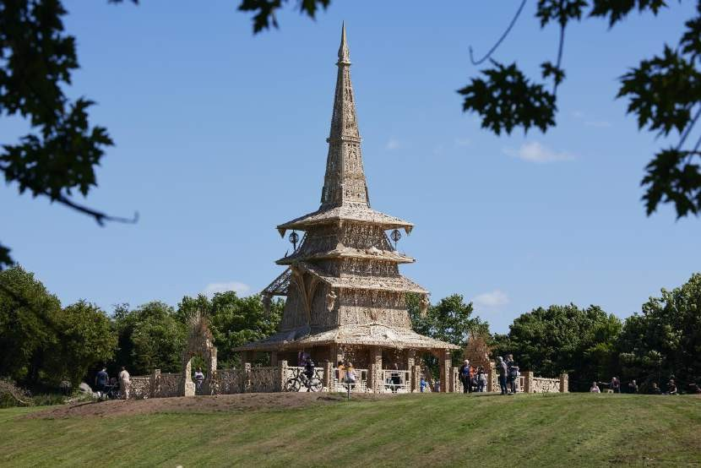
Sanctuary by David Best, produced by Artichoke.
Photo by Matthew Andrews.

Artichoke Background

Artichoke was founded in 2005 with its now legendary presentation of Royal de Luxe's The Sultan's Elephant, which brought London to a standstill with audiences transfixed by the surprise arrival of a giant puppet and a time-travelling elephant. The production brought joy to hundreds of thousands of people as they explored the capital and turned it into a playground for a day. It challenged the political arts establishment to rethink its largely venue-based approach to large cultural events and demonstrated the potential for the temporary transformation of the public realm through the creation of a moment of extraordinary art.

Over the last 17 years, Artichoke has produced more than 20 ground-breaking productions ranging from PROCESSIONS, a living portrait of women in the 21st Century celebrated across the UK; One & Other, Antony Gormley's 2400-hour living

portrait on the Fourth Plinth in Trafalgar Square; Peace Camp, a lyrical set of installations created by Deborah Warner and Fiona Shaw for the London 2012 Festival, to the Lumiere Festivals produced in Durham, Derry-Londonderry and London. Lumiere 2021 was the seventh edition of the festival in Durham and has set the benchmark for outdoor city-wide winter arts events, having become a core feature of the cultural landscape.

In September 2016 Artichoke produced London’s Burning, a four-day festival of arts and ideas, to commemorate the 350th anniversary of the Great Fire of London. Across the City of London, six international works invited audiences to reflect on the scale and impact of the historical fire, whilst also considering contemporary threats to London’s survival.

At the centre of the festival was London 1666, an extraordinary sculptural representation of the sixteenth-century skyline of London, conceived by American artist David Best, and built by a team of young Londoners who worked with professional carpenters to realize the artist’s vision. Floated down the Thames on barges, the 120m sculpture was burnt on the river in central London in a spectacular reminder of the events of 4th September 1666.

Most recently, in May 2022, Artichoke produced Sanctuary, A Covid Memorial for the Nation, the third in its memorial series designed by David Best working with the local community of Nuneaton & Bedworth.

The Role

Artichoke is seeking a fast-learning, enthusiastic and organised Communications Coordinator to join our busy London-based team. The ideal candidate will be passionate and driven, with an interest in arts & culture marketing and communications, a thirst for learning and a keen eye for detail. As a supporting position to the whole Communications team, this role offers the opportunity to develop varied experience in all aspects of arts Communications. This role will suit someone who is looking for their next career step and who will rise to the challenge of working in a fast-paced, creative environment.

Company structure

Artichoke is a charity, funded as a National Portfolio Organisation by Arts Council England. Under the guidance of the Board chaired by Stephanie Flanders, Helen Marriage, Artichoke’s founding director, leads the organisation. The permanent staff team of 20 is divided across the core departments of Production; Development; Communications and Administration. The core staff devote their time to delivering the programme of large-scale projects initiated by the Artistic Director.

HOW TO APPLY
Please read the information in the job description and person specification on the following pages.

  - Please read the information in the job description which can be found here: https://www.artichoke.uk.com/category/jobs/
  - Complete the application form which can be found here

  - Details about applying via alternative methods are available, please contact:
recruitment@artichoke.uk.com | 0207 650 7611 Closing date for applications: Thursday 23rd June at 9am. Interview date: W/C 4th July 2022. Details to be confirmed. Start date: July 2022, depending on notice period.
Artichoke is an Equal Opportunities employer and is committed to equality and diversity within our workforce and all opportunities provided by Artichoke. We particularly encourage people from under-represented backgrounds to apply. Positive action may be used in the recruitment process to select a candidate from a group that is disadvantaged or under-represented in our workforce if the candidates in question are of equal merit.

Artichoke is a Disability Confident Committed employer.

Please do email recruitment@artichoke.uk.com to arrange a call if you have any questions or queries about the role.

APPENDIX I

JOB DESCRIPTION | COMMUNICATIONS COORDINATOR

Job Title: Communications Coordinator

Based: London. Currently E1. Some travel around the UK will be required.

Reports to: Head of Digital

Key relationships: Head of Digital, Senior Communications Manager;
Communications Director; Artichoke core staff; External partners and service providers.

The Role

Artichoke is seeking a fast-learning, enthusiastic and organised Communications Coordinator to join our busy London-based team. The ideal candidate will be passionate and driven, with an interest in arts & culture marketing and communications, a thirst for learning and a keen eye for detail. As a supporting position to the whole Communications team, this role offers the opportunity to develop varied experience in all aspects of arts Communications. This role will suit someone who is looking for their next career step and who will rise to the challenge of working in a fast-paced, creative environment.

The Communications Coordinator will provide organisational, digital and administrative support to the Communications Team. They will work closely with the Head of Digital to create digital and design content including social media assets, website content, commissioned texts and interviews to reach and expand our audience.

The Communications Coordinator will also take specific responsibility for some of the essential communications tasks including media monitoring, the maintenance of Artichoke’s image library and using brand assets to design and produce reports and presentations.

Responsibilities Digital
- Assist the Head of Digital in the day-to-day management of Artichoke websites including writing blog content and artist interviews, news items and updating archiving content as needed
- Support with growing Artichoke’s social media presence across our social channels (Instagram, Facebook, Twitter, YouTube and TikTok)
- Creating social media content to reach and expand our audience, planning and managing a monthly posting schedule and engaging followers in conversation around Artichoke’s work
- Using social media evaluation tools to support the Head of Digital in producing reports of digital activity for each Artichoke project as and when required

- Support the Head of Digital in coordinating the production and delivery of all Artichoke film and audio content
- Manage Artichoke’s mailing list and newsletter, ensuring the list is up to date, encouraging new sign-ups, liaising with all Artichoke teams to source content, write copy and track engagement
- Support in the delivery of digital sponsor benefits, maintaining sponsor logos and credits online
- Research and identify visual arts and culture websites and social media channels to collaborate with to direct audiences to Artichoke channels

Marketing and Press
- Support the communications team in the delivery of project marketing campaigns including copywriting, print distribution and advertising campaigns
- Support the communications team with research requirements including media and marketing campaign research including social media influencers
- Act as the main point of contact for Artichoke’s media monitoring service, track press coverage, circulate a weekly clippings update, maintain the press cuttings archive and produce reports where required
- Manage and maintain the Artichoke image archive and work with Artichoke’s
press team to respond to media image requests

Organisational support to the communications team
- Assist with creating presentations for external events
- Maintain an overview of the team’s work schedule including monitoring project deadlines, coordinating key internal and external communications meetings and producing agendas and minute-taking
- Assist with coordination of team travel
- Act as the main point of contact for the communications team enquiries and answer in a timely manner
- Support the Communications team at fundraising and press events

General
- Contribute to the development of a professional working and learning environment within the organisation
- Contribute to the organisation’s understanding of diversity and its implications for the arts and ensure that this understanding informs all the organisation’s activities
- Ensure adherence to the organisation’s policies and procedures with particular reference to equal opportunities; children and vulnerable adults and health and safety
- Work in a flexible manner in line with the organisation’s corporate objectives
and the role and be willing to undertake other duties as reasonably requested
- Provide excellent customer care in dealings with the public
- Deputise for senior colleagues as appropriate
- The ability and willingness to work flexible hours and travel as required

Knowledge and Skills required / Person Specification
Desirable
Essential

Friendly and collegiate personal approach | Experience in working with the public
Able to work on own initiative and prioritise a complex range of tasks | Design skills including knowledge of  Adobe Suite such as In-Design and Photoshop or willingness to learn
Able to relate to a wide range of people | Knowledge of database management
Ability to work in a high pressure and fast-paced environment | Arts industry knowledge
Proactive team player who responds to  challenges with flexibility and positive solutions | Video and audio editing skills
Excellent writer and editor, with clear succinct style and good attention to detail | Experience with using a CRM or ticketing system such as Patronbase, Spektrix or Tessitura
1 year’s work experience in a similar role
Understanding of the role social media plays in organisational branding, visibility and audience development
Experience in creating social media plans and professional content for Facebook, Instagram, Twitter, YouTube, Instagram and TikTok
CMS / web management skills e.g Wordpress
Analytics skills e.g experience with
social media insights and creating reports
Proven administrative skills
Proficient in MS Word, Excel and PowerPoint
Proven good time management skills

This job description is not exhaustive and the post holder may be required to undertake other such duties from time to time.

SUMMARY OF TERMS AND CONDITIONS

Salary: Salary £24,000-£27,000 gross per annum, dependent on skills & experience, paid monthly in arrears

Contract: This is a full-time, permanent position, subject to successful completion of the three-month probationary period.

Annual leave: 25 days per annum, plus an additional day’s annual leave for each year’s service (capped at 5 days). You will also be entitled to Bank Holidays.

Probationary period: 3 months

Notice period: 2 months’ notice period (one month during probationary period)

Location: The post is based in Artichoke’s offices, currently in London E1. At times you may be asked to work from home due to the Covid19 pandemic and restrictions imposed by the UK Government.

Hours of work: Hours of work will inevitably vary according to the nature of the workload, but generally will be a minimum of 35 hours per week, Monday – Friday, 10am – 6pm. Additional hours may occasionally be required as necessary for the successful performance of the job, but overtime or time off in lieu will not be given.

Benefits:

- Pension: Artichoke is enrolled in a pension scheme with Standard Life. Upon 3 months service payments can be made into your pension.

- Income protection scheme: Artichoke has an Income protection insurance policy to help if you cannot work because you are ill or injured.

- Employee Assistance programme: An Employee Assistance Programme (EAP) is a counselling and information service. It’s specifically designed to give you the practical and emotional support you may need for everyday life.

- Group Life Insurance: All permanent staff are enrolled in a scheme which will pay 4 times a deceased individual’s salary to a named beneficiary.

- Cycle to work scheme: Artichoke purchases the bike on behalf of the employee at a reduced retail price, saving the employee tax and NI. The cost of the bike is deducted from the employee’s gross monthly salary.

- Season ticket Loan: Artichoke offers an interest-free loan to staff needing to pay for a season travel ticket.

- Eye tests and Glasses: Artichoke offers to pay for an eye test every year for staff members, up to £30, and for prescription glasses for up to the value of
£150.

- Parental leave: For staff that have been employed for over a year, Artichoke offers an enhanced Parental leave policy that offers more than statutory pay.

Artichoke is an equal opportunities employer.

